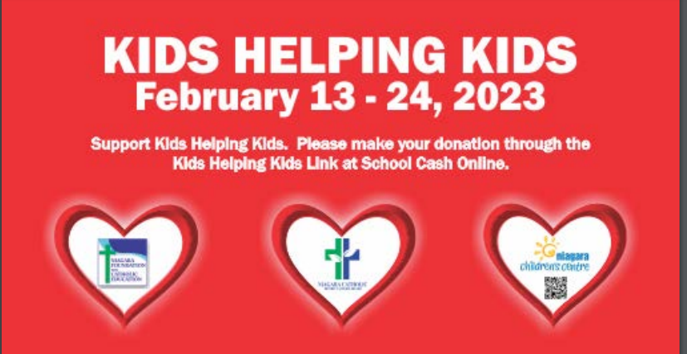

Kids Helping Kids Fundraiser

St. Mary Catholic Elementary School NF

February 12th - February 23th, 2024

**To participate in Kids Helping Kids** **visit School Cash-On-Line**

* Participate in all activities for $5.00. This includes one guess for the Valentine’s Candy Jars; Purchase additional guesses for the Valentine’s Candy Jar 5 for $2.00.
* Candy Grams are also available for $1.00 each on School Cashonline- only week of Feb.12-15
* Will be delivered at last recess each day.

**School Cashonline will be available from February 1, 2024 to February 22, 2024**

**Valentine’s Cards and Celebrations:** As we have in the past, we will celebrate Valentine’s Day on Wed. Feb 14th, with classroom activities. Students are welcome to bring in Valentine’s Cards for their classmates.

**Please do not bring food items.**

|  |  |
| --- | --- |
| **Monday,**  **12th** | **Wacky Hair Day or Hat Day**  **Guess Candy in Jar** |
| **Tuesday,**  **13th** | **Shrove Tuesday aka ‘Pancake Day’**  **Guess Candy in Jar**  **\*\*Happy Valentine’s Day Eve**  **Celebrating with Valentine Cards,Crafts & Activities on Tuesday and not on Wednesday Feb. 14 as per the Board’s direction**  **It’s an Out of Dress Code Day!! Wear Red, White or Pink** |
| **Wednesday,**  **14th** | **ASH WEDNESDAY SERVICE**  **Valentine Cookies for students who ordered**  **Guess Candy in Jar** |
| **Thursday,**  **15th** | **100th Day of School**  **Primary Students Celebrate with 100th Day Activities**  Dress like 100 years old or bring in something of 100  Popcorn Day for those students who ordered  **Family Math Night @ St. Mary** 4:45 pm to 6:00 pm |
| **Friday, 16th** | **PA Day - NO SCHOOL** |

Kids Helping Kids Fundraiser

St. Mary Catholic Elementary School NF

February 13th - February 23th, 2022

|  |  |
| --- | --- |
| **Monday,**  **19st** | **Family Day - NO SCHOOl** |
| **Tuesday,**  **20th** | **Fav. Singer or Jersey or Band’ Shirt Day**  **Guess Candy in Jar** |
| **Wednesday,**  **21st** | **Winter Carnival**  **Morning activities**  **Guess Candy in Jar** |
| **Thursday,**  **22nd** | **Valentine Craft Day**  **Guess Candy in Jar** |
| **Friday,**  **23rd** | Dance A Thon  **Announce Candy in Jar Winner** |

**Kids Helping Kids is a fun, informal fundraiser, which supports these causes through paid participation in events. Kids Helping Kids is open to students attending in school and students in our virtual schools. Donations to the Kids Helping Kids fundraiser can be made in School Cash Online. For further information about the Niagara Foundation for Catholic Education, please contact Jim Marino, at 905.735.0240 ext. 210 or jim.marino@nfce.org. To find more about the Niagara Children’s Centre, please visit their website: Niagara Children's Centre**